**Creating an S3 Bucket**

1. Navigate to the **Services** menu at the top and click on **S3** in the **Storage** section.
2. In the left menu, choose Buckets, click **Create Bucket** and fill in the bucket details.
   * Bucket Type Select : **General purpose**
   * Bucket Name: Enter ***whizlabs123***

(**Note:** The Bucket Name must be Unique across all existing bucket names in Amazon S3)

* Object ownership: Select **ACLs disabled (recommended)** option
* Bucket settings for Block Public Access: **Uncheck** the option, **Block** all **public access** and select the check box option of Acknowledgment.

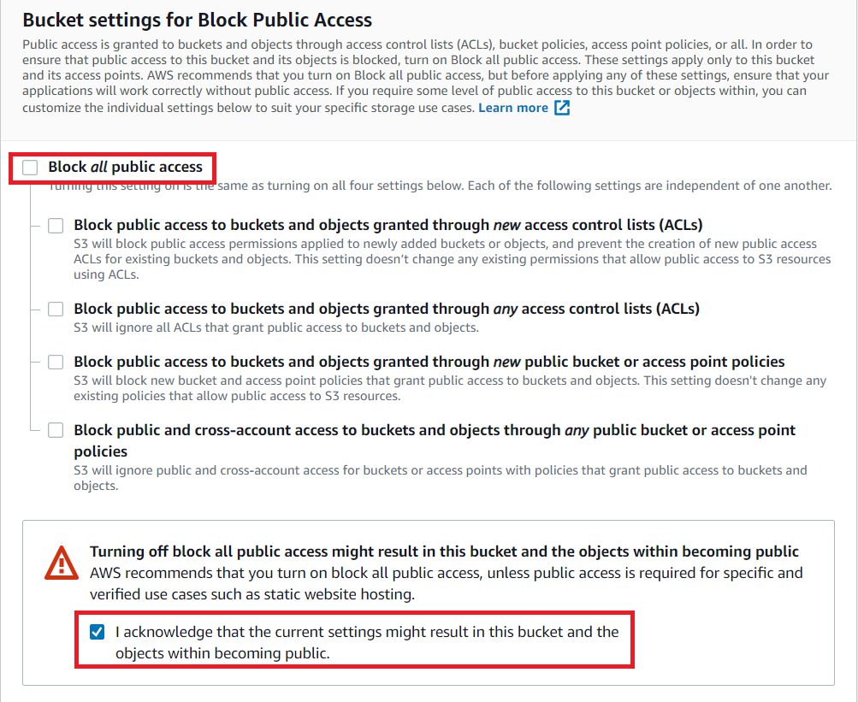

* Leave other settings as default.
* Click on the **Create Bucket** button.

1. Your S3 Bucket is now created.

**S3 Bucket Naming Requirements**

1. The bucket name can be between **3** and **63** characters long, and can contain only **lower-case characters, numbers, periods, and dashes**.

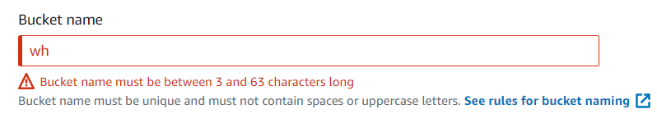

1. Each label in the bucket name must start with a lowercase letter or number.

1. The bucket name cannot contain underscores, end with a dash, have consecutive periods, or use dashes adjacent to periods.

1. The bucket name cannot be formatted as an IP address (198.51.100.24)

1. Because S3 allows your bucket to be used as a URL that can be accessed publicly, the bucket name that you choose must be globally unique.
2. Try these and see the warnings you get while creating the bucket.

**Task 3: Exploring S3 Bucket**

1. Click on your bucket name.
2. In the **Objects**, you can Upload the Objects, Create Folder and segregate the objects.

1. Click on **Properties**. Here, you can set various properties for your Bucket.
   * **Bucket Versioning**: Keeps multiple versions of an object in the same bucket.
   * **Default encryption**: Automatically encrypts objects when stored in Amazon S3.
   * **Tags:** Shows the Bucket tags.
   * **Static website hosting**: Hosting a static website, which does not require server-side technologies.

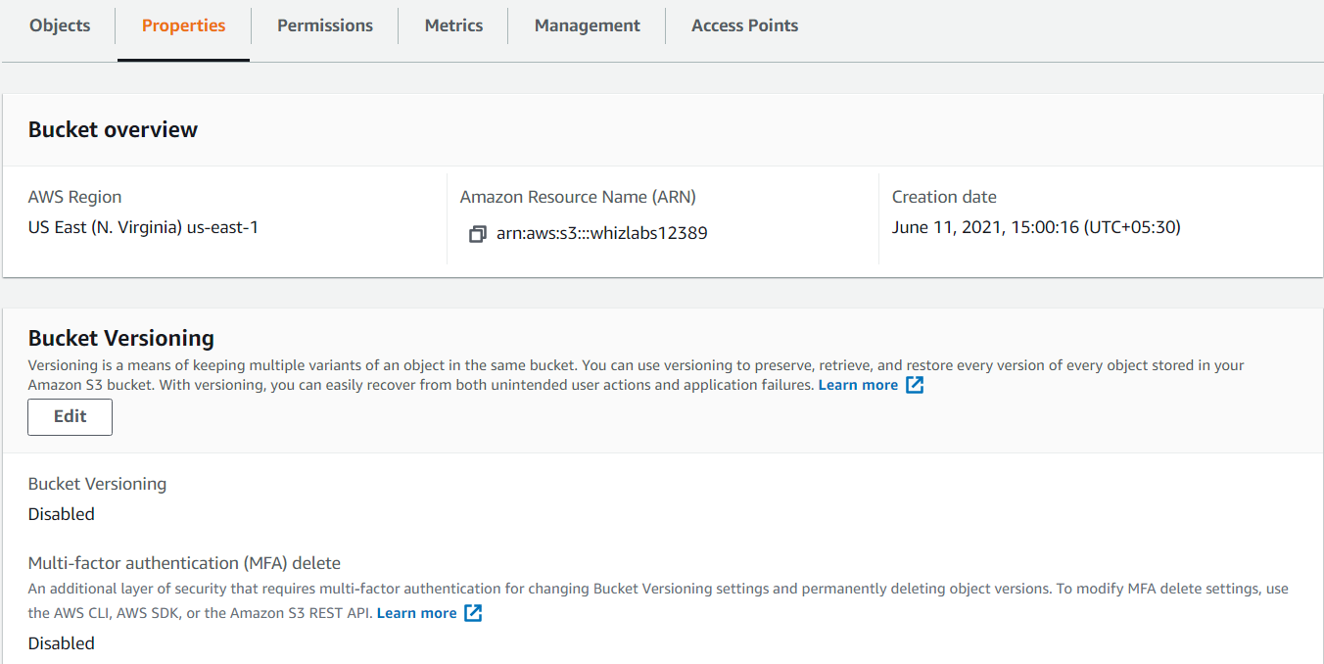

1. Click on **Permissions**. You can specify the permissions for accessing your bucket.
   * Block Public Access: In order to ensure that public access to all your S3 buckets and objects is blocked, you can turn on Block all public access.
   * Bucket Policy: Bucket Policy uses JSON-based access policy language to manage advanced permission to your AWS S3 resources.
   * Access Control List: ACLs are used to grant basic read/write permissions to the other AWS Accounts.
   * CORS Configuration: Cross-origin resource sharing (CORS) defines a way for client web applications that are loaded in one domain to interact with resources in a different domain.

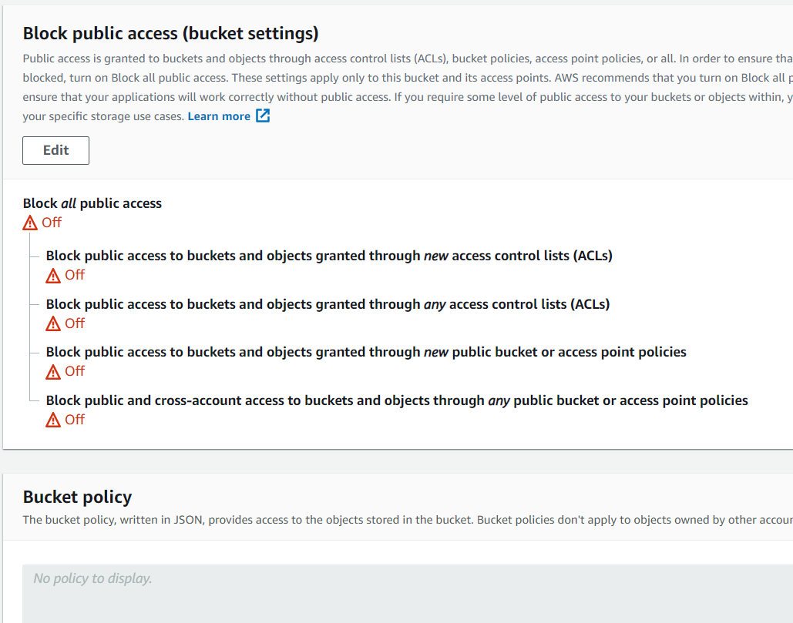

1. Click on **Metrics.** Here you can explore the usage, request, and data transfer activity within your bucket.

1. Click on **Management**. Here, you can manage your bucket with features like Lifecycle, Replication, Analytics, Metrics and Inventory.

1. Click on **access points**. Access points can be used to provide access to your bucket.

